# User Manual

## Table of Contents:

* System Design Overview
  + System Design for Frontend
    - useApi Hook
  + System Design for Backend
    - ApiResponse Class
    - Overriding Default Responses in Spring
* Authentication System
  + Authentication System for Backend
  + Authentication System for Frontend
  + Flow of Authentication
  + Testing
  + Security Considerations
* Streak System
  + Overview
  + How Streaks Work
  + Getting Started
  + Maintaining Your Streak
  + Breaking a Streak
  + Viewing Your Streak
    - Dashboard Display
  + API Access
  + Technical Details
    - Streak Rules
    - Time Zones
    - Implementation
* Course Recommendation System
  + Course Recommendation System for Backend
  + Course Recommendation System for Frontend
  + Flow of Course Recommendation
* Save to Favourite Courses
  + Save to Favourite Courses for Backend
    - FavouriteCourse Service
    - FavouriteCourse Controller
    - FavouriteCourse Repository
    - Authentication Integration
  + Save to Favourite Courses for Frontend
    - Favourite Courses Dashboard
    - User Interaction
  + Flow of Save to Favourite Courses
    - Saving a Course
    - Removing a Course
* Profile Customization
  + Overview
  + Backend
  + Frontend
  + Error Handling
* Comments System
  + Overview
  + Comments System for Backend
  + Comments System for Frontend
  + Flow of Comments Feature
* Trending Courses
  + Overview
  + Using Trending Courses
    - Accessing Trending Courses
    - Course Information Display
  + API Access
  + Flow of Trending Courses
    - View Counting
    - Course Selection
  + Integration with Other Features
  + Technical Implementation
* Course Goals
  + Overview
  + Using Course Goals
    - Creating a Goal
    - Managing Your Goals
  + Goal Tracking
    - Monitoring Progress
    - Marking Courses Complete
  + API Access
  + Integration with Other Features
  + Technical Implementation
* Badge Achievement
  + Overview
  + Badge Types
  + Viewing Your Badges
  + API Access
  + Flow of Badge Achievement
  + Integration with Other Features
  + Technical Implementation
* User Avatar Feature
  + Backend
    - Profile Management
  + Frontend
  + Flow of Avatar Management
  + Usage Instructions
* Enrollment Tracking Progress
  + How to update time spent
* Friends
  + How to Add / Remove Friends

# System Design Overview

**Author: Justin Fung**

The system is designed to provide a seamless user experience and a robust developer experience. It leverages TypeScript for type safety and security, and employs various DAOs (Data Access Objects) and DTOs (Data Transfer Objects) to ensure data integrity.

# System Design for Frontend

The frontend is built using React and Next.js, with a focus on modularity and reusability. The useApi hook is a central piece of the frontend, handling API requests and managing their states.

#### **useApi Hook**

The useApi hook simplifies API interactions by managing loading, error, and response states. It uses Axios for HTTP requests and includes automatic token refresh functionality.

1. **Generics for Type Safety**:
   1. Ensures type safety by using TypeScript generics for request and response data.
2. **Axios for HTTP Requests**:
   1. Configured to include credentials and handle cross-origin requests.
3. **State Management**:
   1. Manages states like isLoading, isError, message, status, and data.
4. **Automatic Token Refresh**:
   1. Includes an Axios interceptor to handle token refresh automatically if the access_token expires.
5. **Error Handling**:
   1. Provides comprehensive error handling for network, server, and client errors.

### **System Design for Backend**

The backend is built using Spring Boot, with a focus on security and scalability. The ApiResponse class standardizes API responses, ensuring consistency across endpoints.

#### **ApiResponse Class**

The ApiResponse class encapsulates the response structure for API endpoints, including fields for status code, message, and data.

1. **Generic Type Parameter**:
   1. Allows the class to be used with any type of data, providing flexibility and type safety.
2. **Status Code**:
   1. Stores the HTTP status code of the response.
3. **Message**:
   1. Stores a descriptive message about the response.
4. **Data**:
   1. Stores the actual data being returned in the response.
5. **Static Factory Methods**:
   1. Simplify the creation of ApiResponse objects and ensure consistency in the response structure.

### **Overriding Default Responses in Spring**

To provide more consistent and informative responses, default Spring Boot error responses are overridden.

1. **ValidationExceptionHandler**:
   1. Handles validation exceptions and provides custom error responses.
2. **AccessDeniedHandler**:
   1. Handles access denied exceptions and provides custom error responses.
3. **AuthenticationEntryPoint**:
   1. Handles authentication exceptions and provides custom error responses.

# Authentication System

**Author: Justin Fung**

The authentication system uses JWT for secure authentication and authorization, ensuring that only authorized users can access certain resources.

### **Authentication System for Backend**

1. **JWT Authentication Filter**:
   1. Intercepts incoming HTTP requests and checks for JWT tokens in cookies.
   2. Bypasses the filter for login, signup, refresh, and public endpoints.
   3. Verifies tokens and sets the authentication context if valid.
2. **JWT Service**:
   1. Handles the generation and verification of JWT tokens.
   2. Provides methods to generate access_token and refresh_token cookies.
3. **Authentication Controller**:
   1. Provides endpoints for user signup, login, token refresh, and logout.
4. **User and Role Management**:
   1. Manages user and role entities in the database.
   2. Handles user-related operations like finding a user by username and saving a new user.
5. **Security Configuration**:
   1. Configures Spring Security to use JWT for stateless authentication.
   2. Sets up CORS, CSRF, and session management policies.

### **Authentication System for Frontend**

1. **Authentication Pages**:
   1. LoginPage and SignUpPage components provide forms for user login and signup.
   2. Use the useApi hook to make API requests for authentication.
2. **API Hook**:
   1. Handles API requests and responses, including automatic token refresh.
3. **Authentication Provider**:
   1. Provides authentication context to the entire application.
   2. Checks authentication status by making a request to the /auth/me endpoint.
4. **Protected Routes**:
   1. Navbar component displays different links based on the authentication state.
   2. Provides links to login, signup, profile, and logout.

### **Flow of Authentication**

1. **Signup**:
   1. User submits the signup form.
   2. Frontend sends a POST request to /auth/signup.
   3. Backend creates a new user, generates JWT tokens, and returns them in cookies.
   4. Frontend sets the authentication state and redirects the user to the home page.
2. **Login**:
   1. User submits the login form.
   2. Frontend sends a POST request to /auth/login.
   3. Backend authenticates the user, generates JWT tokens, and returns them in cookies.
   4. Frontend sets the authentication state and redirects the user to the home page.
3. **Token Refresh**:
   1. When an API request fails with a 401 status, the frontend automatically sends a POST request to /auth/refresh.
   2. Backend verifies the refresh_token, generates a new access_token, and returns it in a cookie.
   3. Frontend retries the original API request with the new access_token.
4. **Logout**:
   1. User clicks the logout button.
   2. Frontend sends a POST request to /auth/logout.
   3. Backend invalidates the JWT tokens by setting their cookies with a max age of zero.
   4. Frontend updates the authentication state and redirects the user to the home page.

### **Security Considerations**

1. **Password Encryption**:
   1. Uses BCryptPasswordEncoder to encrypt user passwords before storing them in the database.
2. **Token Expiration**:
   1. access_token has a short expiration time (15 minutes).
   2. refresh_token has a longer expiration time (365 days).
3. **HttpOnly and Secure Cookies**:
   1. JWT tokens are stored in HttpOnly and Secure cookies to prevent client-side scripts from accessing them.
4. **CORS Configuration**:
   1. Allows cross-origin requests from trusted origins (e.g., <http://localhost:3000>).
   2. Specifies allowed methods, headers, and credentials to ensure secure cross-origin communication.

# Streak System

**Author: Zain Altaf**

### **Overview**

The Streaks feature rewards users for consistent daily engagement with the platform by tracking consecutive daily logins.

### **How Streaks Work**

#### **Getting Started**

* A streak counter is automatically created when you register a new account
* Your streak is visible on your dashboard
* Initial streak starts at 1 on your first login

#### **Maintaining Your Streak**

* Log in at least once each day to maintain your streak -- note that staying logged in will also allow you to maintain/increase your streak
* Streak increases by 1 for each consecutive day you log in
* Multiple logins in the same day count as one streak day

#### **Breaking a Streak**

* Missing a day of login will reset your streak

### **Viewing Your Streak**

#### **Dashboard Display**

* Located on the main dashboard

#### **API Access**

To check your streak programmatically:

GET /api/streak/{userId}

(Remember that this data is accessed from the backend so it will show on backend port -- localhost:8080)

### **Technical Details**

#### **Streak Rules**

* Only one streak update per calendar day
* Streak calculations occur automatically during:
  + Token refresh
  + Authentication events -- Login or Signup

#### **Time Zones**

* Streaks are calculated based on your local calendar date
* Days are determined using system default time zone

### **Implementation**

**Streak.java**

* Each user has an associated Streak object that contains the following data:
  + Id -- primary key
  + Streak -- the counter value
  + previousLogin -- the date when the streak was last incremented
* The user object and streak object are stored in separate tables in the database with user where streak contains a foreign key that points to the user id it is associated with.
* The related streak object is linked with the user object upon authentication

**AuthService.java**

* The related streak object is linked with the user object upon authentication
* Within the authserivce file is a method named checkAndUpdateStreak which takes the user and increments their streak if they haven't already done so today
* This method is called within each of the authentication service functions -- signup, login, refresh

**StreaksService.Java**

* In this class I have included methods to increment a streak by the user that it is associated with and updating the values within the db
* I have also created a linked function to just save the streak that is passed through to the db

**StreakRepository.Java**

* findByUserId method allows you to find the streak associated with a specific user

# Course Recommendation System

**Author: Daniel Dineen**

The course recommendation system analyzes student profiles and course data to suggest relevant courses based on academic history, preferences, and similarity to other students' choices, while continuously improving recommendations through user feedback.

### **Course Recommendation System for Backend**

1. **Course Service**
   1. Implements hybrid recommendation algorithm (collaborative and content-based filtering)
   2. Analyzes student's favourite courses for personalized recommendations
   3. Manages recommendation by difficulty level
2. **Course Controller**
   1. Handles course recommendation API endpoints and searches
   2. Processes course ratings and filtering requests
   3. Routes authenticated requests to services
3. **Course Repository**
   1. Manages course data and similarity matrices in database
   2. Handles course metadata and prerequisites
   3. Implements efficient data retrieval and caching
4. **Student Profile Repository**
   1. Manages student profiles and course history
   2. Updates recommendation parameters based on interactions
   3. Maintains student similarity metrics
5. Authentication Integration
   1. Ensures secure access to recommendations
   2. Manages role-based feature access
   3. Integrates with JWT authentication

### **Course Recommendation System for Frontend**

1. **Recommendation Dashboard**
   1. Displays personalized course recommendations with relevance scores and details
   2. Implements dynamic filtering and sorting capabilities (difficulty, schedule, ratings)
   3. Shows course compatibility with current schedule and academic progress
2. **Course Search & Interaction**
   1. Provides advanced search with real-time filtering based on student preferences
   2. Enables course enrollment, wishlist management, and review submissions
   3. Updates recommendations automatically based on user interactions
3. **Student Profile Interface**
   1. Displays academic progress, course history, and recommended course path
   2. Allows preference updates for recommendation refinement
   3. Shows personalized course suggestions based on career goals and interests

### **Flow of Course Recommendation**

1. **Initial Recommendation Generation**
   1. System analyzes student profile, academic history, and preferences upon login
   2. Generates personalized course list using hybrid filtering algorithm
   3. Ranks recommendations based on relevance scores and prerequisites
2. **User Interaction & Refinement**
   1. User can filter recommendations by multiple criteria (difficulty, schedule, ratings)
   2. System updates recommendations in real-time based on user interactions
   3. Course selections and ratings automatically refine future recommendations
3. **Course Selection Process**
   1. User reviews detailed course information and compatibility
   2. System verifies prerequisites and schedule conflicts
   3. Updates student profile and recommendations upon enrollment

# Save to Favourite Courses

**Author:** Sonny Powell

## **Save to Favourite Courses for Backend**

### **FavouriteCourse Service**

* Manages adding, removing, and retrieving favourite courses
* Stores user-course relationships in the database
* Ensures duplicate courses aren't added

### **FavouriteCourse Controller**

* Handles API requests for saving and retrieving favourites
* Routes authenticated requests to the service
* Validates user permissions for modifying favourites

### **FavouriteCourse Repository**

* Manages database interactions for favourite courses
* Efficiently retrieves a user's saved courses
* Implements caching for faster access

### **Authentication Integration**

* Ensures only logged-in users can save favourites
* Uses JWT authentication for secure access
* Restricts access to user-specific favourite lists

## **Save to Favourite Courses for Frontend**

### **Favourite Courses Dashboard**

* Displays user's saved courses in an easy-to-access list
* Allows quick navigation to favourite courses
* Supports sorting and filtering

### **User Interaction**

* Users can add/remove courses from favourites with one click
* Updates the backend in real time
* Provides visual feedback on saved courses

## **Flow of Save to Favourite Courses**

### **Saving a Course**

1. User clicks the "Save to Favourites" button
2. API adds the course to the user's favourites list
3. The UI updates to reflect the change

### **Removing a Course**

1. User selects a course to remove from favourites
2. API deletes the course from the favourites list
3. UI updates to show the course is no longer saved

## Profile Customization

**Author: Justin Fung**

### **Overview**

As a student, you can customize your profile to update your personal details and choose an avatar that represents you. This feature is accessible through the /profile endpoint in the backend and the dashboard in the frontend.

### **Backend**

The backend provides an endpoint to update the profile details. The endpoint is /profile and it supports the PUT method. The request should include a JSON body with the following fields:

* username: Your username
* password: Your password
* firstName: Your first name
* lastName: Your last name
* email: Your email address
* avatarLink: A link to your avatar image

Example request:

json

Copy

{  
 "username": "student123",  
 "password": "password123",  
 "firstName": "John",  
 "lastName": "Doe",  
 "email": "[john.doe@example.com](mailto:john.doe@example.com)",  
 "avatarLink": "<http://example.com/avatar.jpg>"  
}

### **Frontend**

The frontend provides a dashboard where you can update your profile details. The profile update form includes fields for your username, password, first name, last name, email, and avatar link. After filling out the form, click the "Update Profile" button to save your changes.

### **Error Handling**

If the profile update fails, an error message will be displayed. Possible error messages include:

* "Invalid access token": The access token is invalid.
* "Nothing changed": No changes were made to the profile.
* "Profile update failed": The profile update failed due to an internal error.
* Test authentication and access control

# Comments System

**Author: Eren Arslan**

### **Overview**

The Comments feature allows users to engage in discussions about courses, share insights, and ask questions. This interactive element enhances the learning experience by creating a community around each course.

### **Flow of Comments Feature**

1. **Viewing Comments**
   1. Navigate to a course detail page
   2. Scroll to the bottom to see the comments section
   3. Comments load automatically with the course details

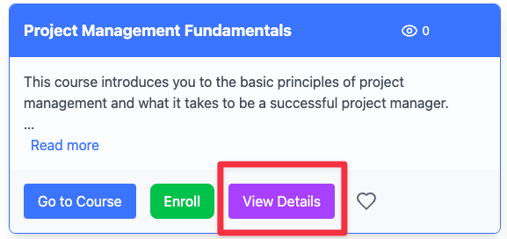

1. **Creating a Comment**
   1. Type your comment in the text area
   2. Click "Post Comment" to submit
   3. New comment appears immediately in the list
   4. Error handling is provided if submission fails

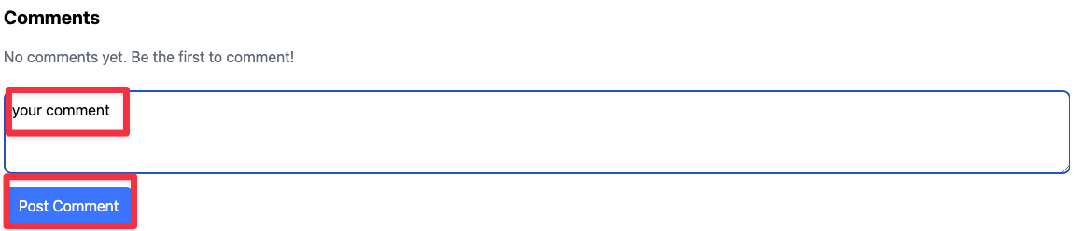

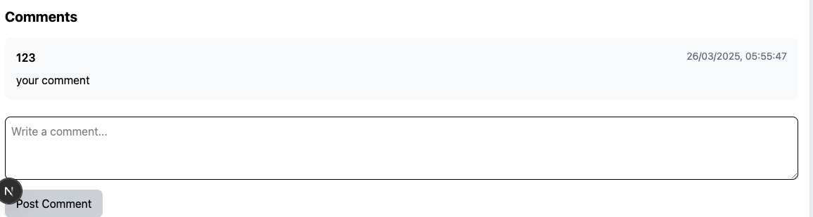

1. **Comment Validation**
   1. Empty comments cannot be submitted
   2. Button is disabled until comment is entered
   3. Feedback is displayed during submission process
   4. Ensure proper validation of input data

### **Comments System for Website**

1. **Comments Section Component**
   1. Displays all comments for a specific course
   2. Shows username and timestamp for each comment
   3. Provides real-time feedback for comment submission
2. **Comment Creation Interface**
   1. Offers a text area for writing new comments
   2. Validates input before submission
   3. Shows loading and error states during submission
3. **Comments Display**
   1. Organizes comments chronologically
   2. Displays "No comments" message when appropriate
   3. Formats dates in a user-friendly manner

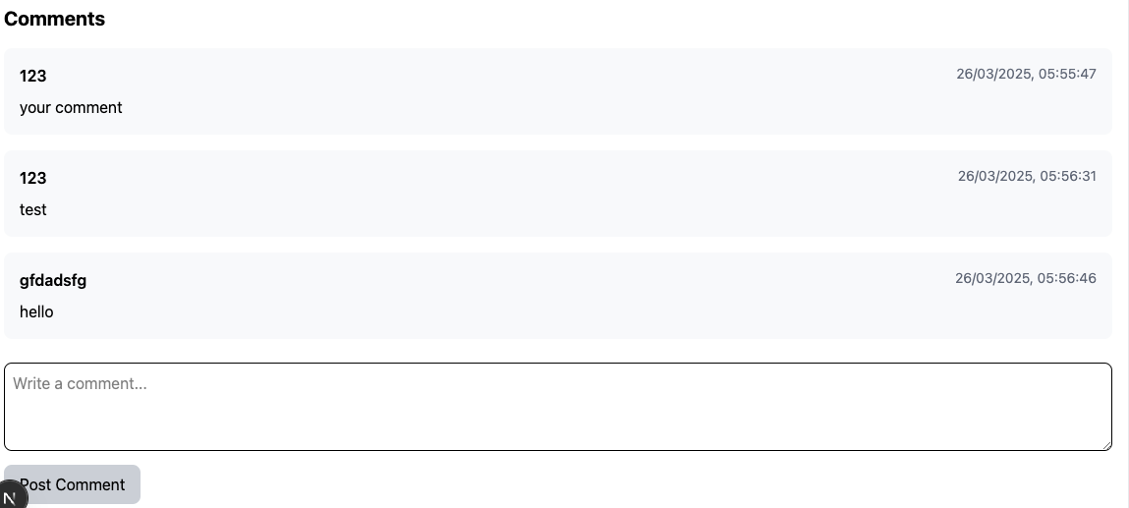

# Badge Achievement – Ibrahim Shahid

How to earn a badge:

1. Currently, badges can only be earned through streaks and favouriting a course. We can use the favourite badge as an example so firstly, favourite a course:  
   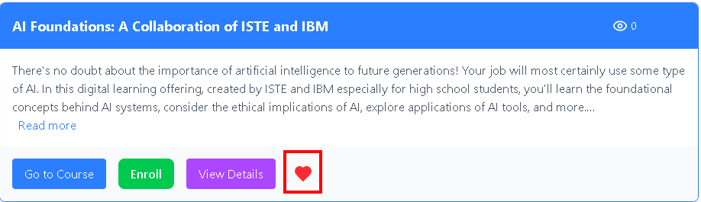
2. Badges will appear in the dashboard once the criteria for the badge has been met

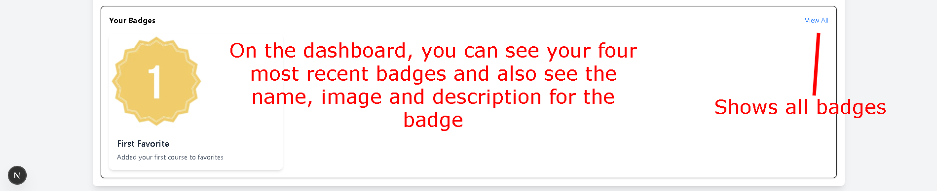

1. Clicking “View All” allows the user to view all his badges, showing all locked and unlocked badges:

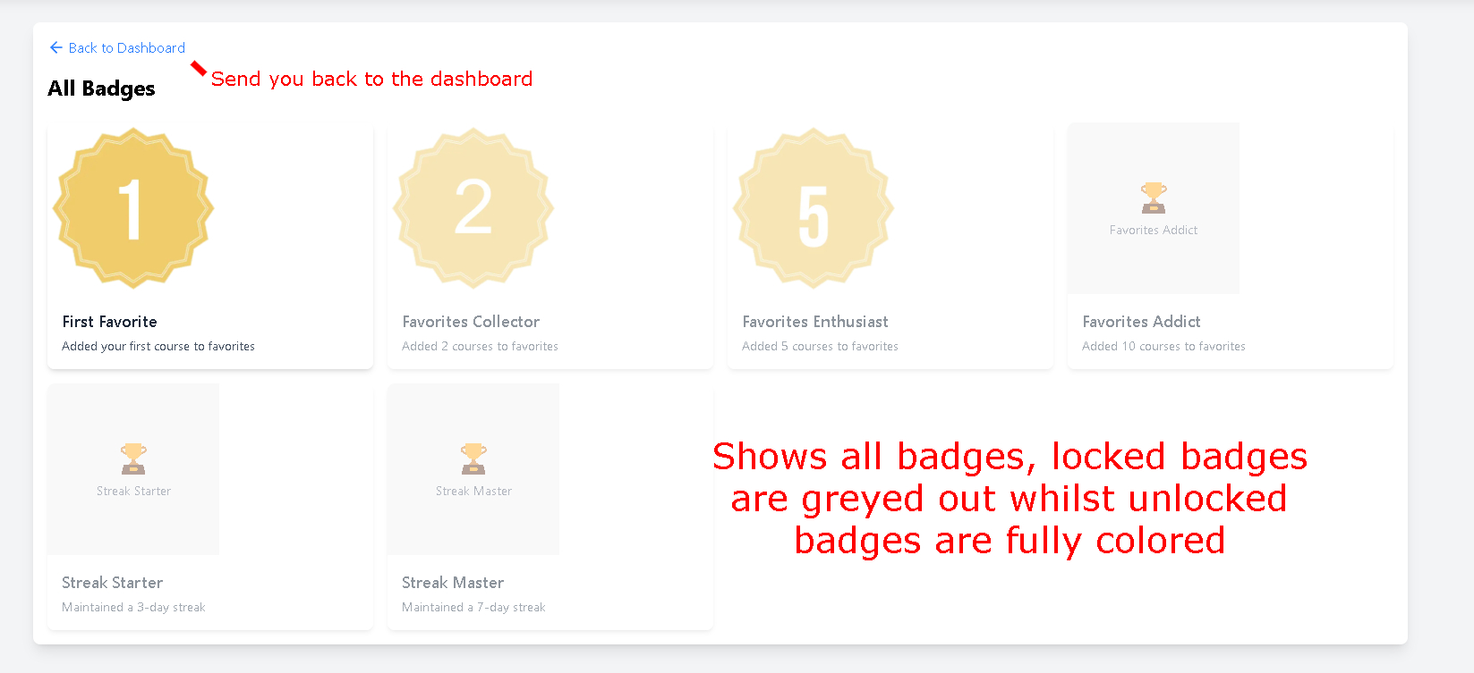

1. (example of more than one badge earnt in the dashboard)

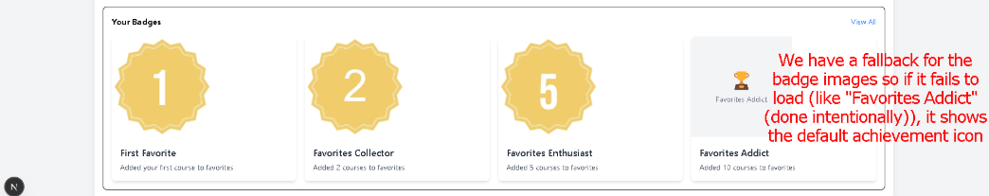

# Trending Courses

Author: Sonny

## **Overview**

The Trending Courses feature highlights the most popular courses on the platform based on view counts. This helps users discover content that others find valuable and increases engagement with high-quality educational materials.

## **Using Trending Courses**

### **Accessing Trending Courses**

* Trending courses are displayed on the main dashboard in a dedicated section
* View the complete list by clicking "See All Trending Courses"
* Courses are automatically sorted with the most viewed courses appearing first

### **Course Information Display**

* Each trending course shows:
  + Course title
  + Brief description
  + Difficulty level
  + View count
  + Estimated duration

## **API Access**

To access trending courses programmatically:

* Get all trending courses: GET /courses/trending

## **Flow of Trending Courses**

### **View Counting**

* Each time a user accesses a course, the view count automatically increments
* 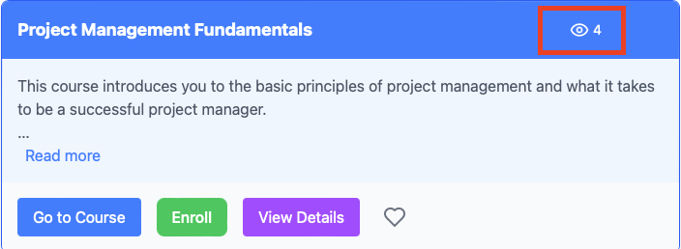
* View counts update in real-time
* The trending list refreshes periodically to reflect the latest popularity metrics
* 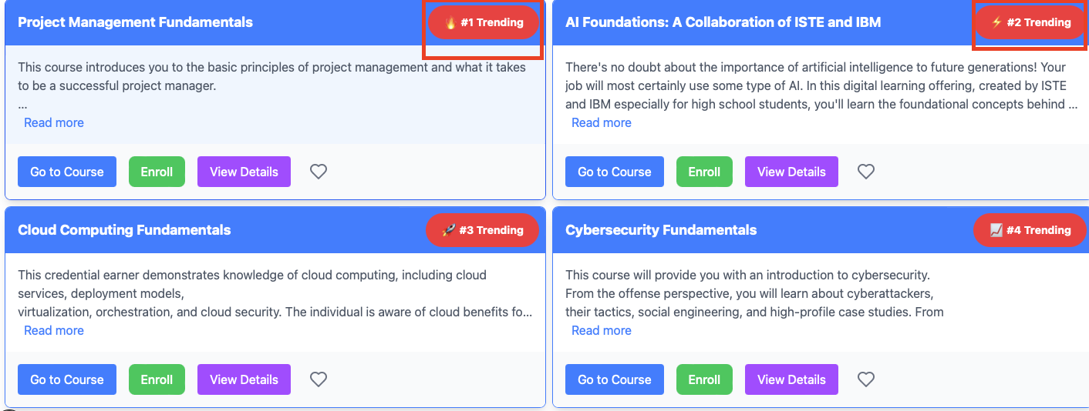

### **Course Selection**

1. Browse the trending courses list

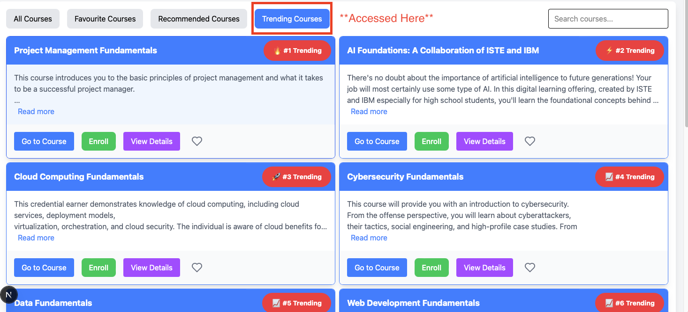

1. Click on any course to view its full details

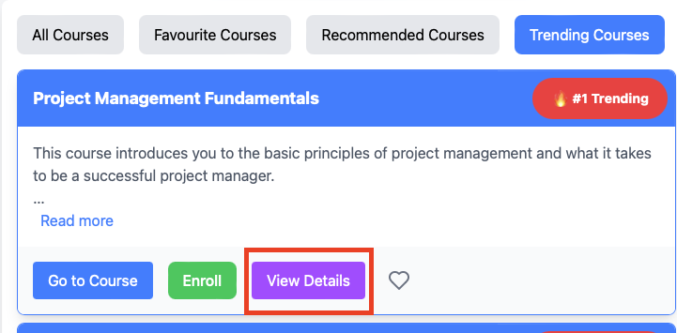

1. Enroll directly from the trending list with a single click

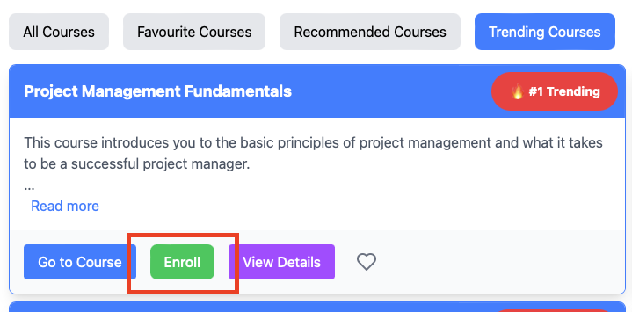

## **Integration with Other Features**

### **Course Recommendation**

* Trending courses may appear in your personalized recommendations
* Popular courses within your difficulty range receive higher recommendation priority

### **Favorites Integration**

* Add trending courses to your favorites with a single click
* Track which trending courses you've already saved

## **Technical Implementation**

The Trending Courses system tracks views and presents the most viewed courses:

* Course views are tracked via the /course

# Course Goals

Author: Zain

## **Overview**

The Course Goals feature enables students to set personalized learning objectives with target dates, rewards, and associated course enrollments. This goal-setting system helps maintain focus, track progress, and increase motivation throughout the learning journey.

## **Using Course Goals**

### **Creating a Goal**

* Set up a new goal from your dashboard by clicking "Create New Goal"
* Specify start and end dates to establish a timeframe
* Add a descriptive name or objective for your goal
* Define a reward to motivate yourself upon completion
* Attach relevant course enrollments to the goal

### **Managing Your Goals**

* View all your current goals on the Goals Dashboard
* Edit goal details including timeframe and description
* Remove goals that are no longer relevant
* Track progress toward each goal visually

## **Goal Tracking**

### **Monitoring Progress**

* Each goal displays a progress bar showing completion percentage
* Connected courses appear beneath each goal with completion status
* Upcoming deadlines are highlighted with time remaining indicators

### **Marking Courses Complete**

* Check off courses as you complete them within a goal
* Toggle completion status for courses that need revision
* Receive notifications when all courses in a goal are completed

## **API Access**

To work with goals programmatically:

* Create a new goal: POST /goals
* Delete a goal: DELETE /goals/{goalId}
* Get all user goals: GET /goals
* Update enrollment completion status: PUT /goals/{goalId}/enrollments/{enrollmentId}

## **Integration with Other Features**

### **Course Enrollment**

* Add existing course enrollments to goals for organized learning paths
* Track which courses contribute to which goals
* Mark courses as complete to update goal progress automatically

### **Profile Customization**

* Goals appear on your profile to showcase your learning commitment
* Completed goals history displays your achievements
* Goal rewards can be customized based on personal preferences

## **Technical Implementation**

The Goals system uses a separate Goal entity with relationships to Person and Enrollment entities. The implementation includes:

* Goal Service for managing goal operations
* Goal Controller for handling API requests
* Goal Repository for database operations

Authentication is integrated to ensure secure access to goal information, using JWT authentication for validation.

* s/{id}/view endpoint
* The top 10 most viewed courses are retrieved using a specialized repository method
* The system ensures accurate view counts with proper error handling

Course Goal Diagrams:

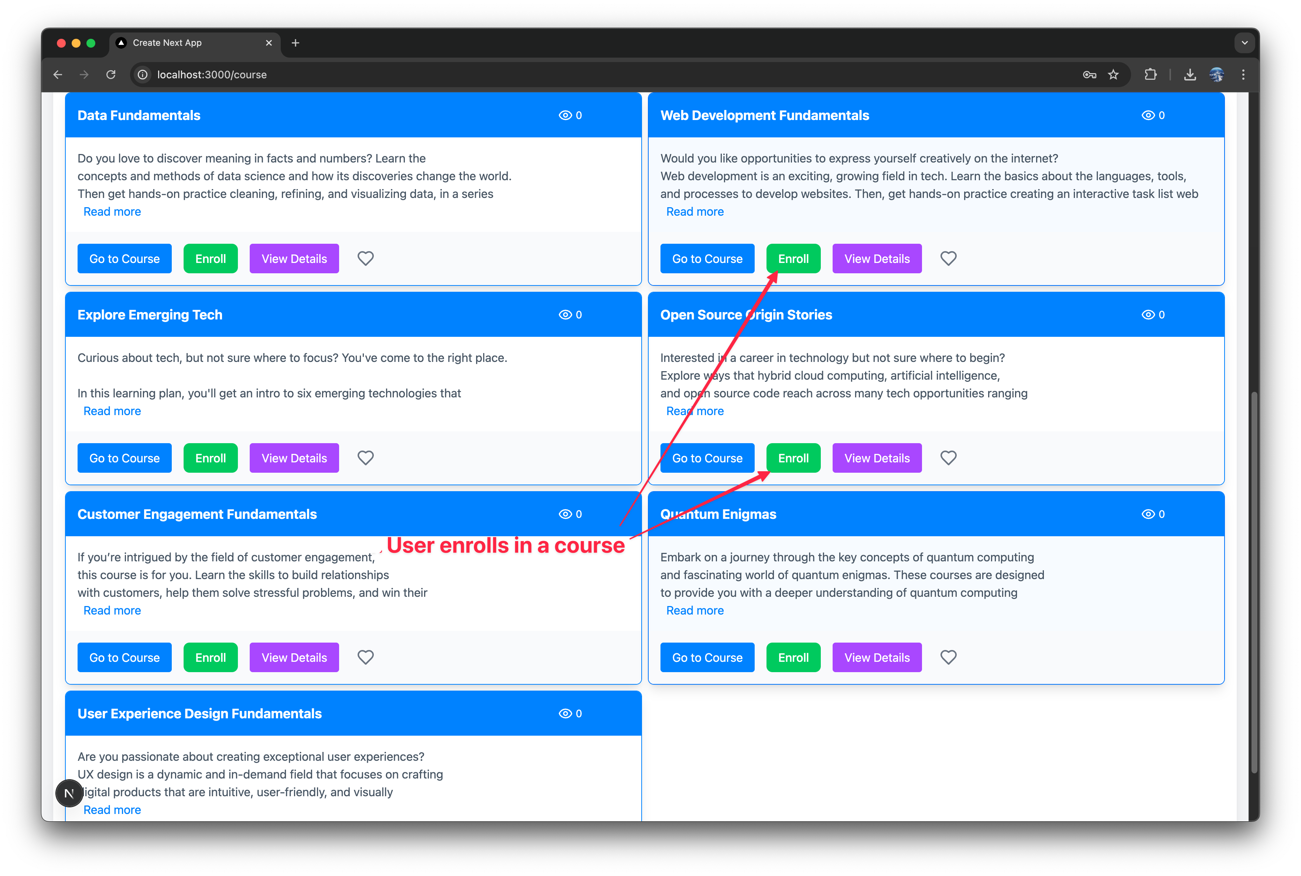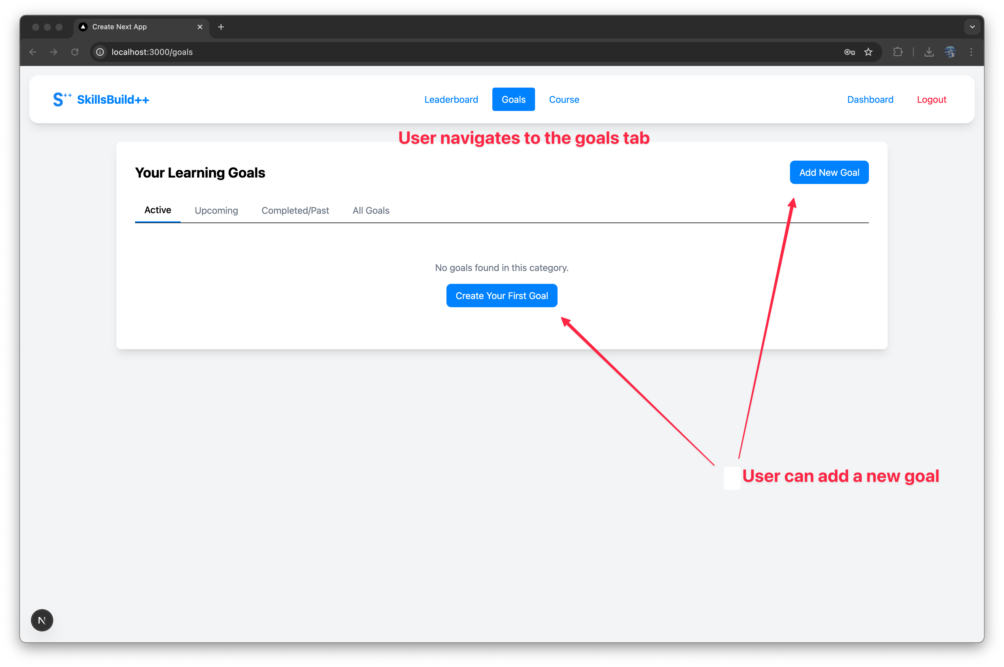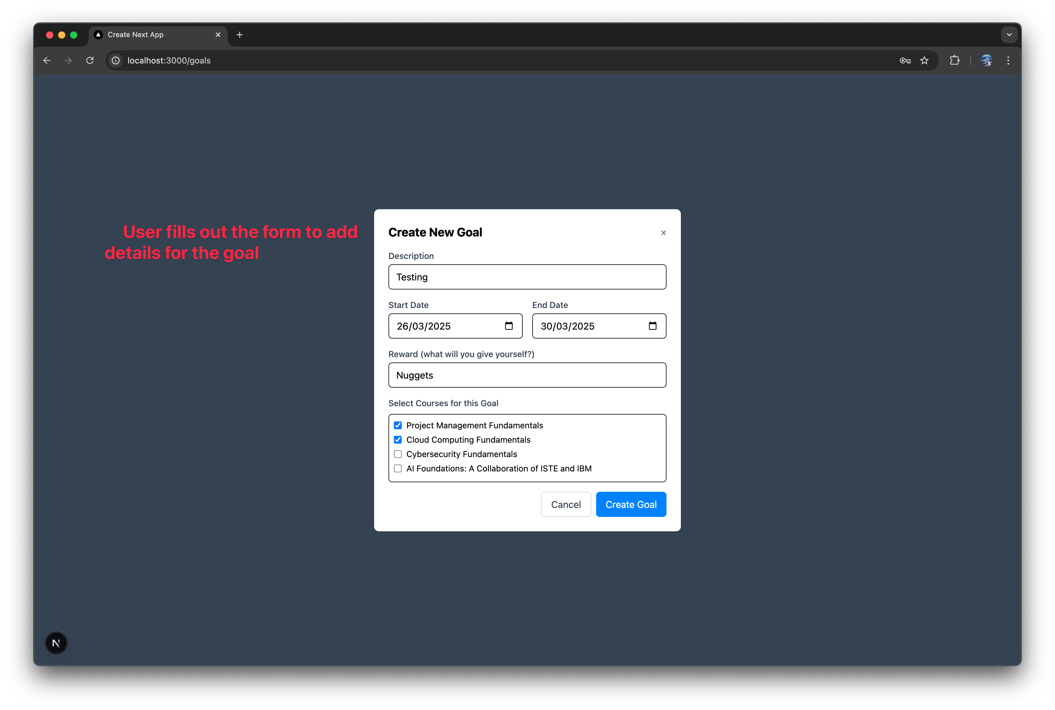

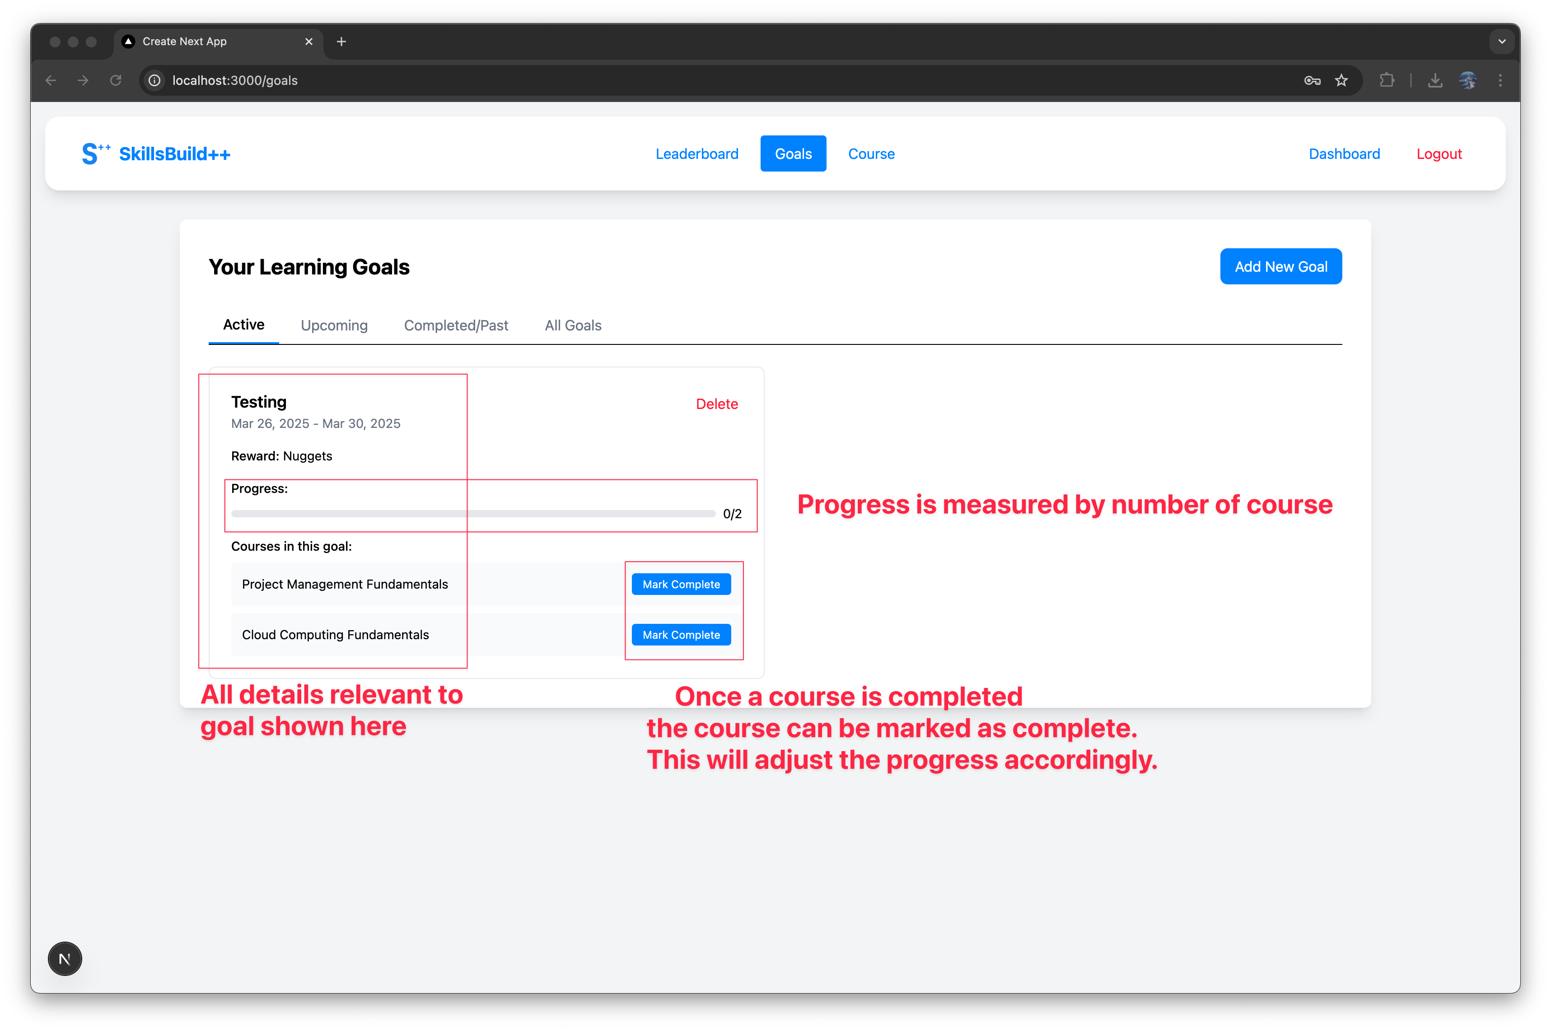

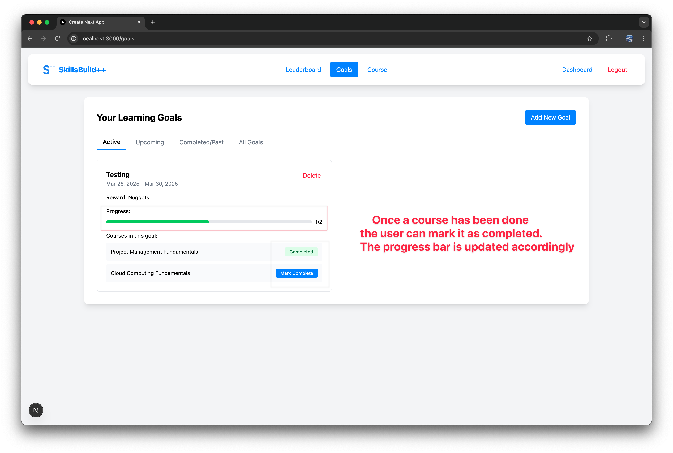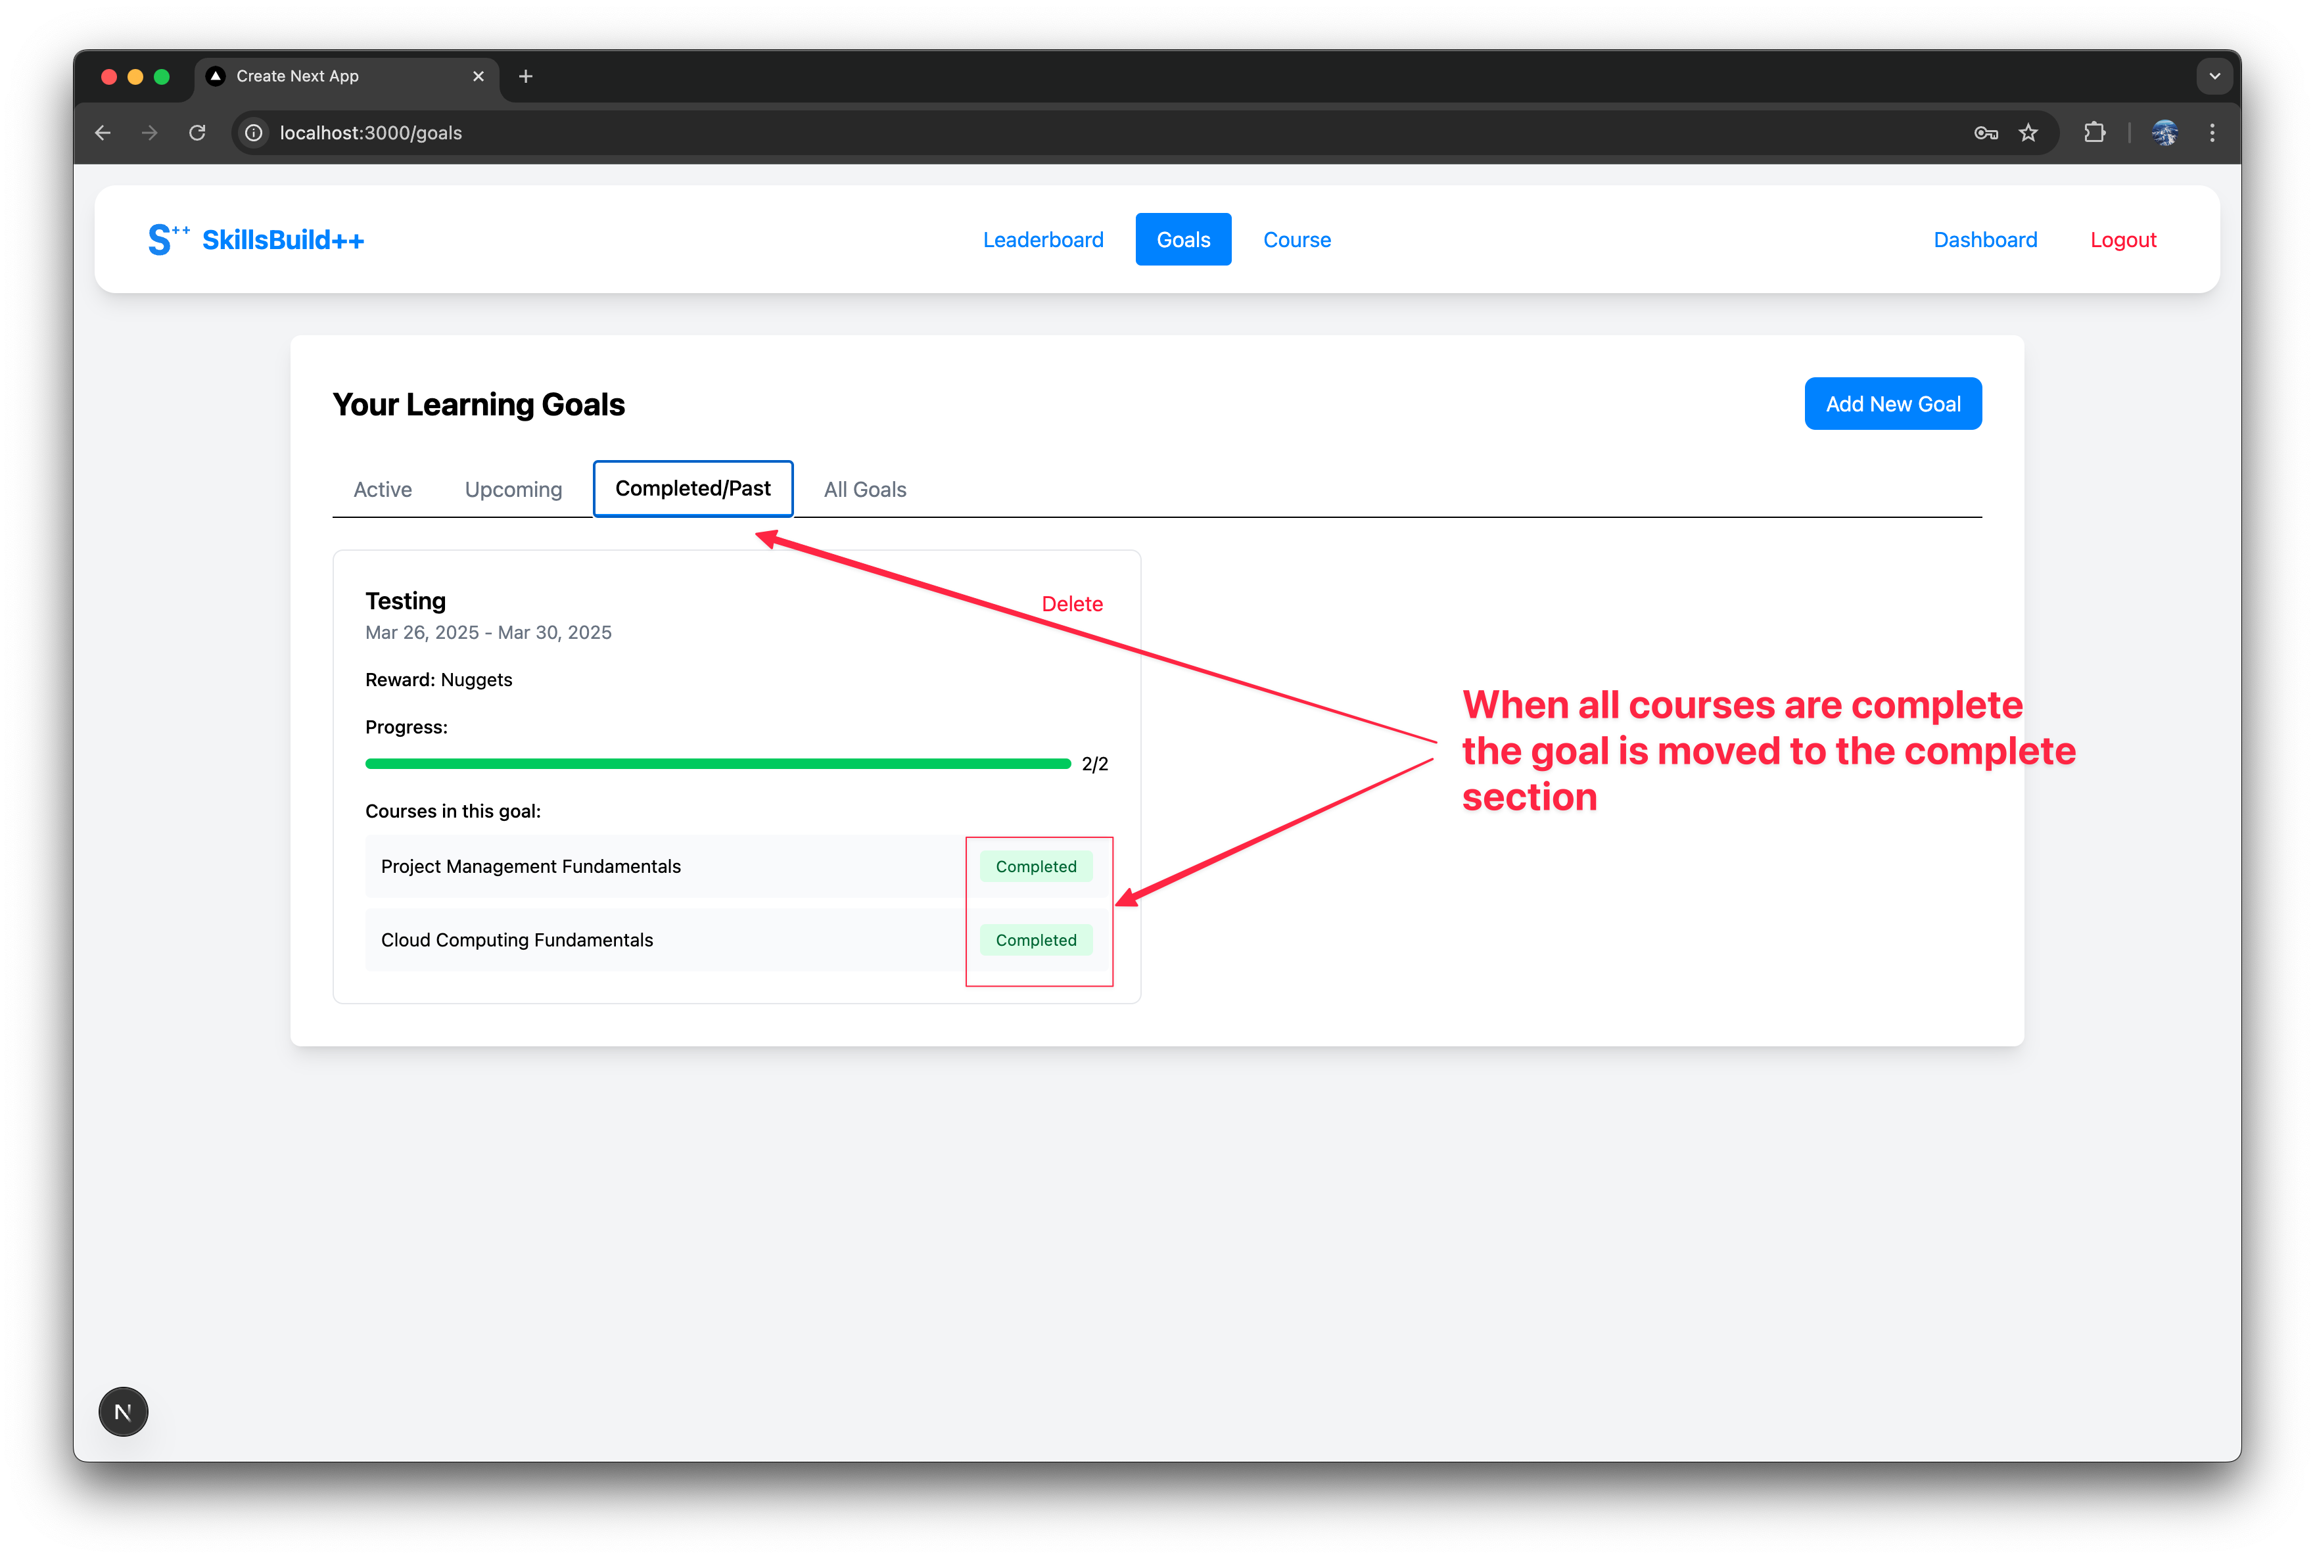

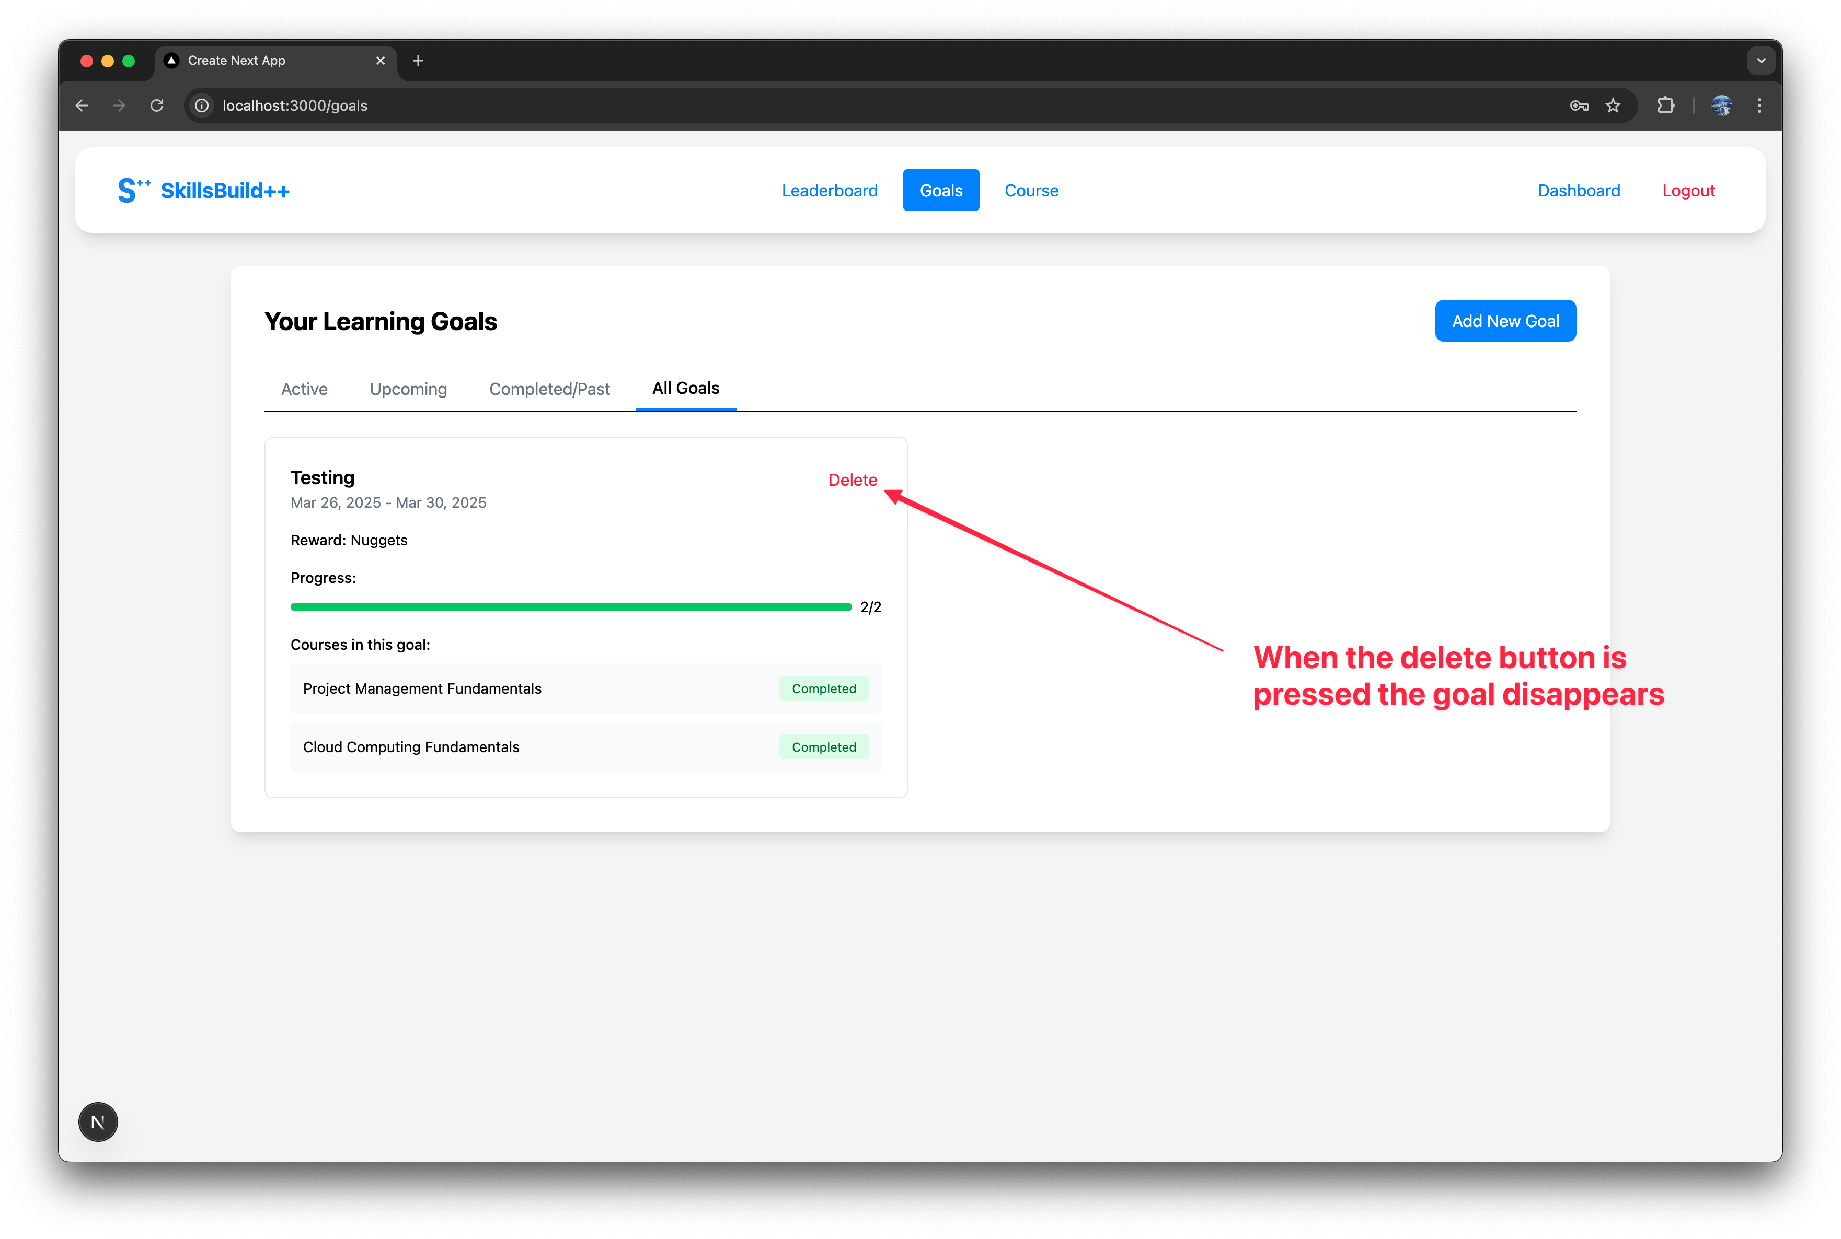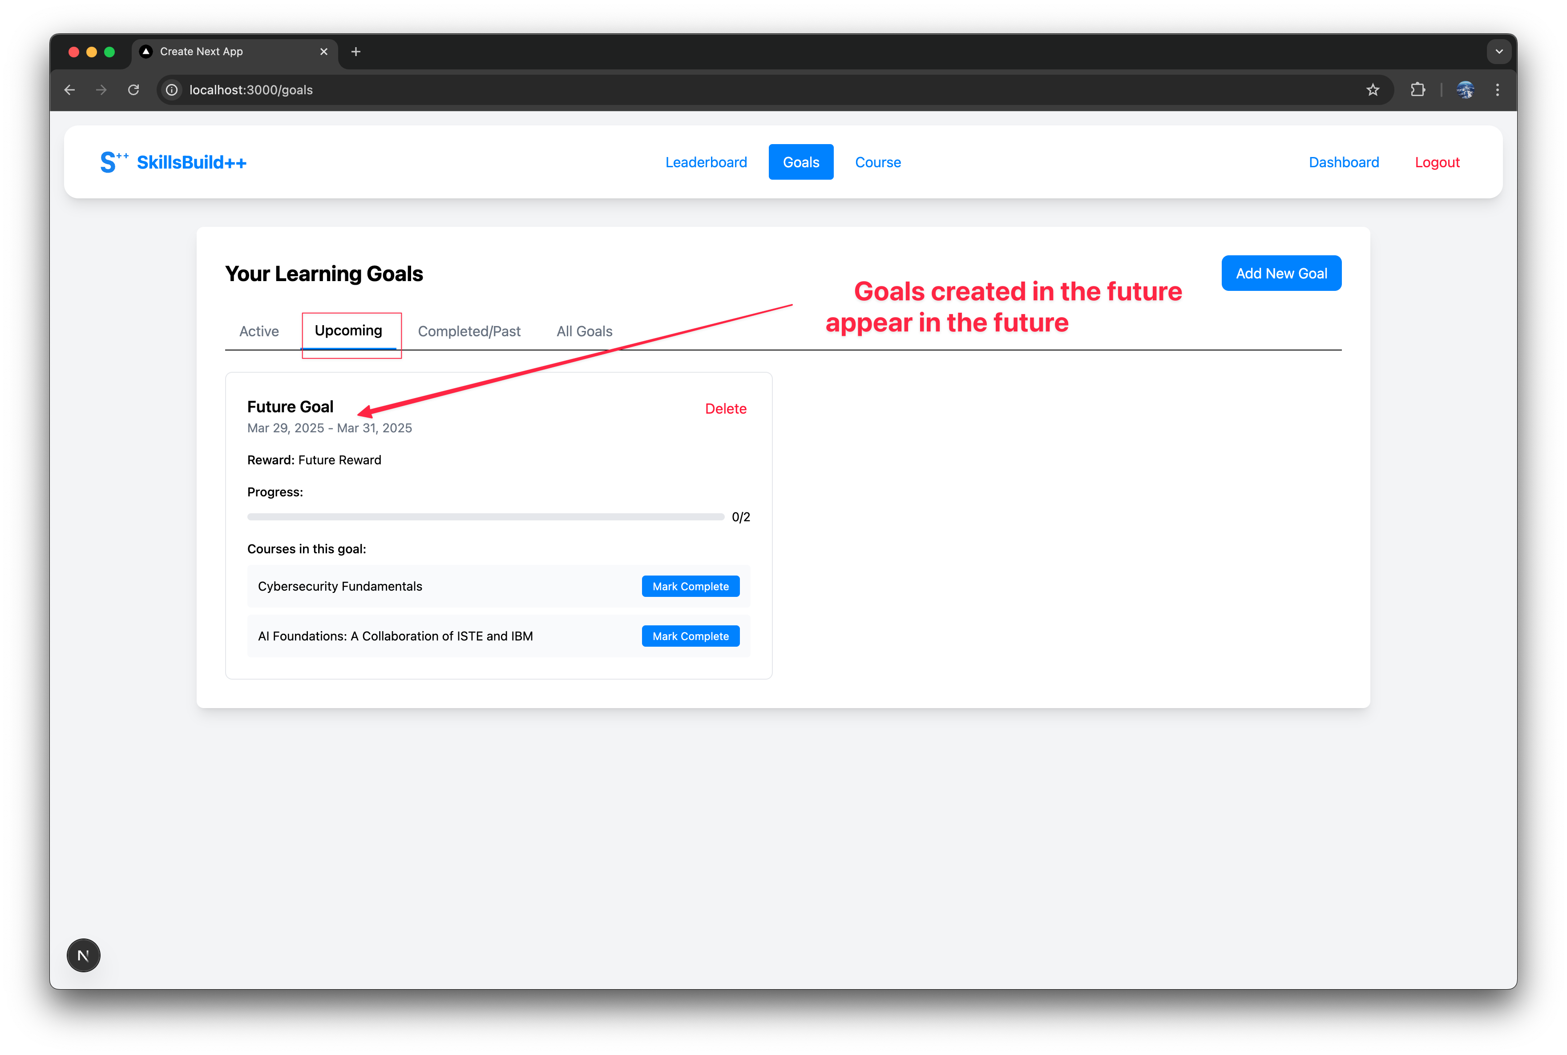

# User Avatar Feature Manual

Author: Daniel Dineen

The user avatar feature allows the user to personalize their profile by adding and displaying profile pictures through URL links; by doing this it may enhance the user identification and platform engagement.

**Backend**

**Profile Management**

**ProfileDTO**

* Handles the avatar URL storage and validation
* Manages avatar link updates through the profile updates
* Integrates with person entity for persistent storage

**Person Entity**

* Stores AvatarLink field for image URL
* Maintains avatar data alongside the other user information
* Provides avatar data access methods

**PersonService**

* Implements avatar URL updates via updatePerson method
* Validates and processes avatar link changes
* Ensures secure avatar link storage

**Frontend**

**Profile Update Form**

**Avatar Input Field**

* Accepts URL input for avatar images
* Validates URL format and accessibility
* Updates avatar display in real-time

**Avatar Display**

* Shows current avatar in navigation bar
* Displays default placeholder if no avatar is set
* Maintains aspect ratio and size consistency

**Profile Management Interface**

* Allows users to view current avatar
* Provides interface to update avatar URL
* Shows preview of avatar changes

**Flow of Avatar Management**

**Avatar Update Process**

1. **User Access**

* Navigate to dashboard
* Access profile update section
* Locate the avatar URL input field

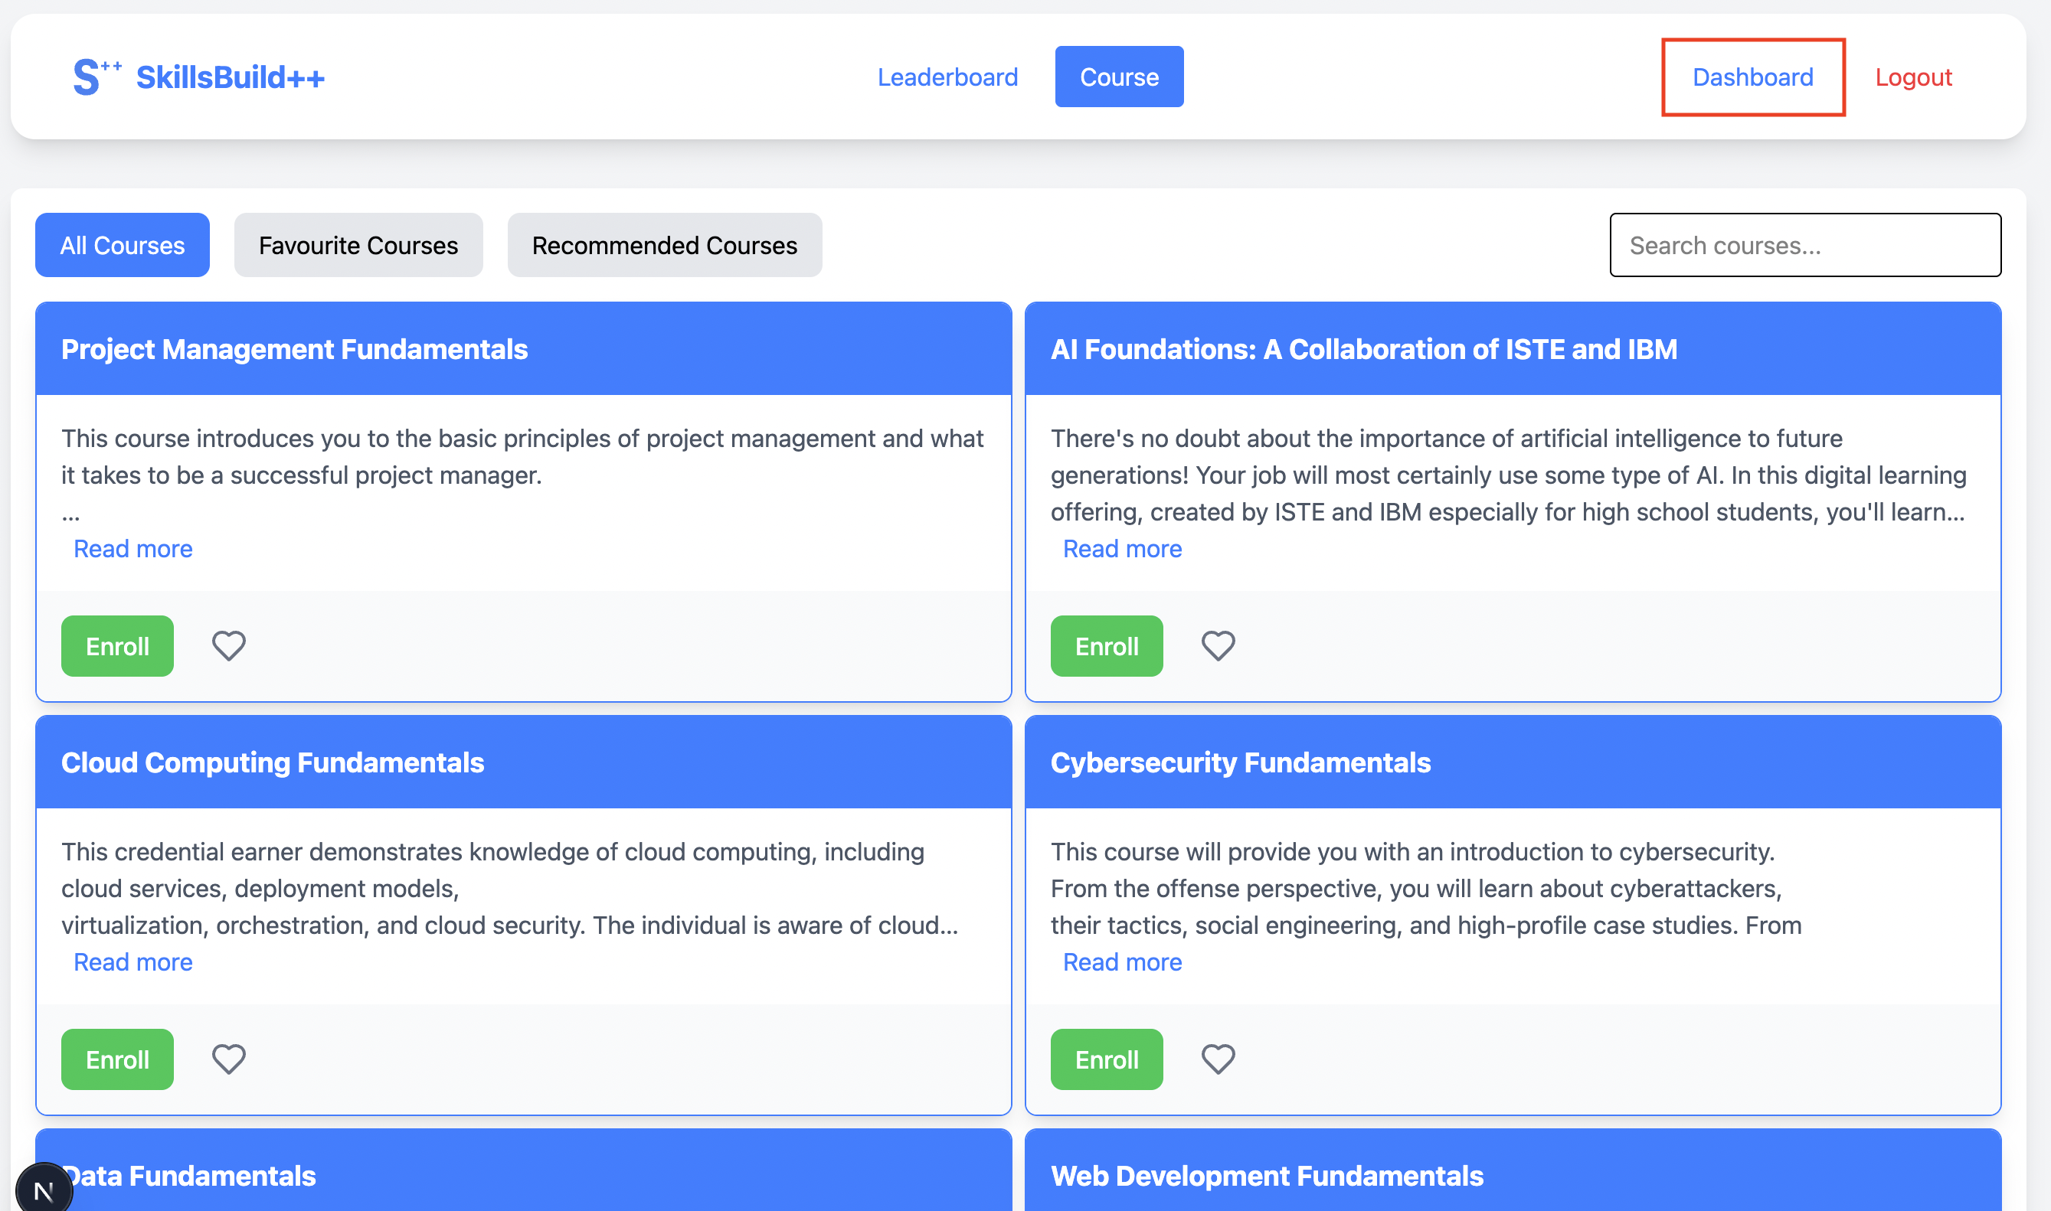

1. **URL Submission**

* Enter valid image URL
* Submit profile update form
* System validates URL format

1. **Display Update**

* Avatar updates in the navigation bar
* Profile section displays the new avatar
* All changes persist across sessions

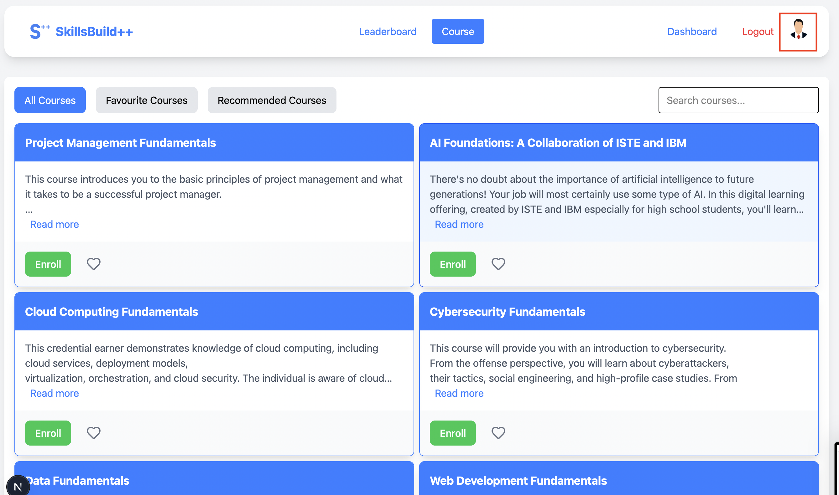

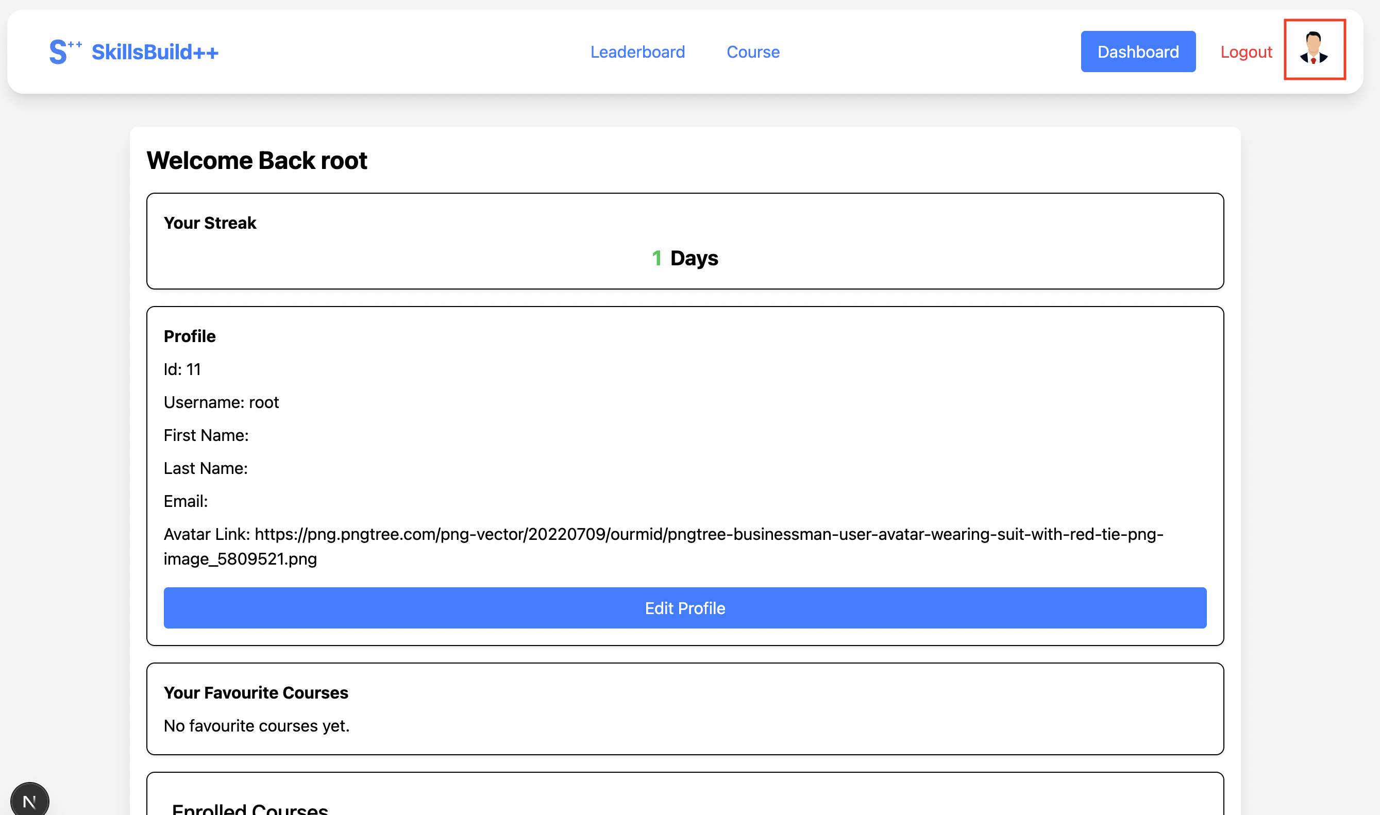

**Usage Instructions**

1. **Accessing Avatar Update**

* Log into account
* Navigate to the dashboard
* Click “Edit Profile”

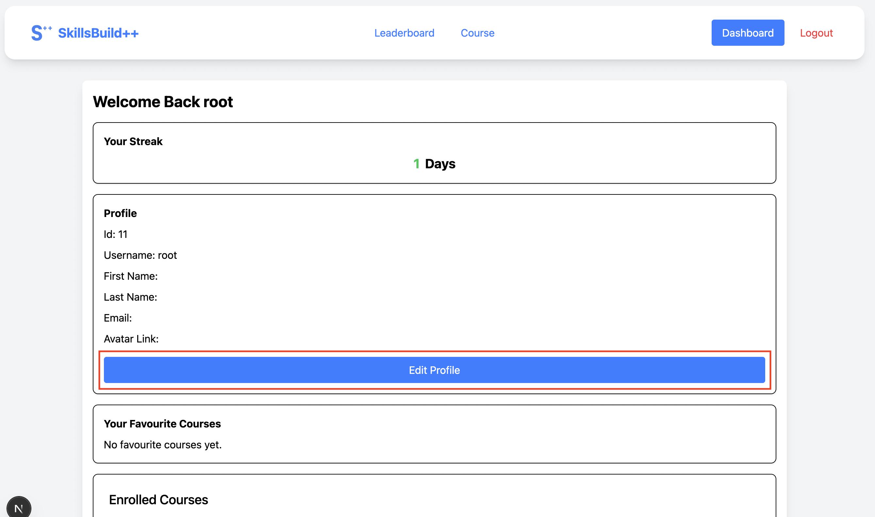

1. **Adding/Updating Avatar**

* Locate “Avatar Link” field
* Enter Valid image URL
* Click “Update Profile”

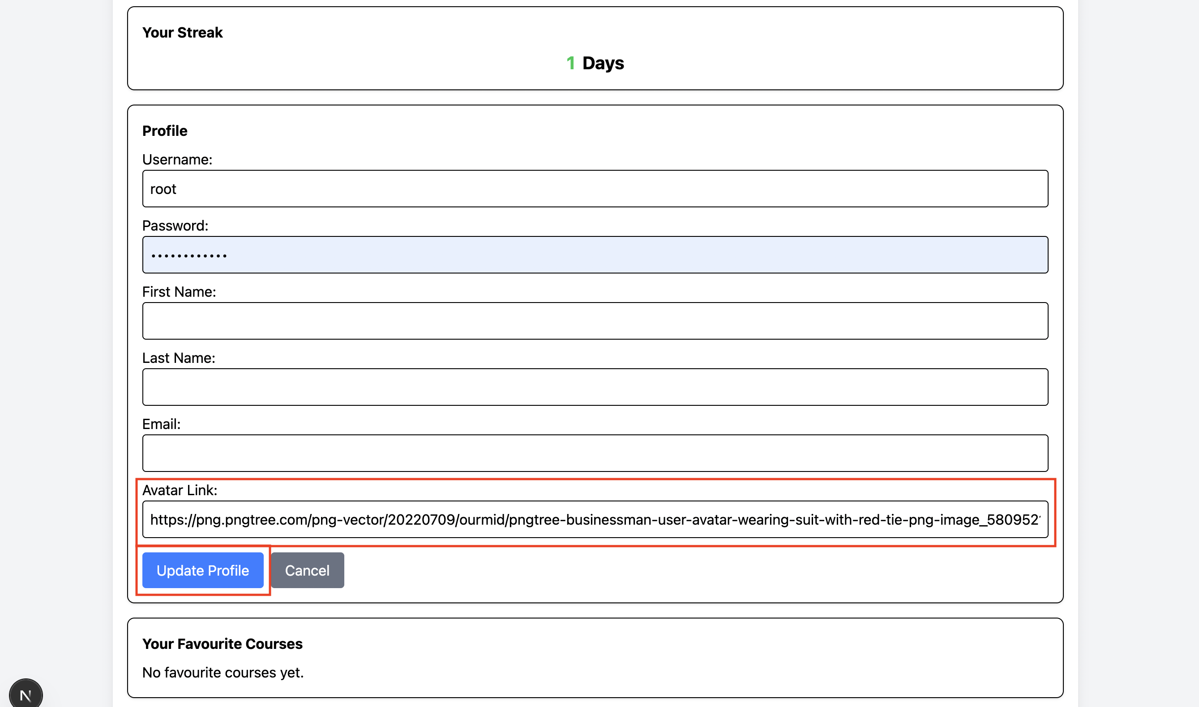

1. **Viewing Avatar**

* Check navigation bar for avatar display
* View profile section for the confirmation
* Verify avatar persistence after refresh

# Enrollment Tracking Progress – Justin Fung

## How to update time spent

1. Make sure you are enrolled in a course by clicking the enroll button in /course endpoint.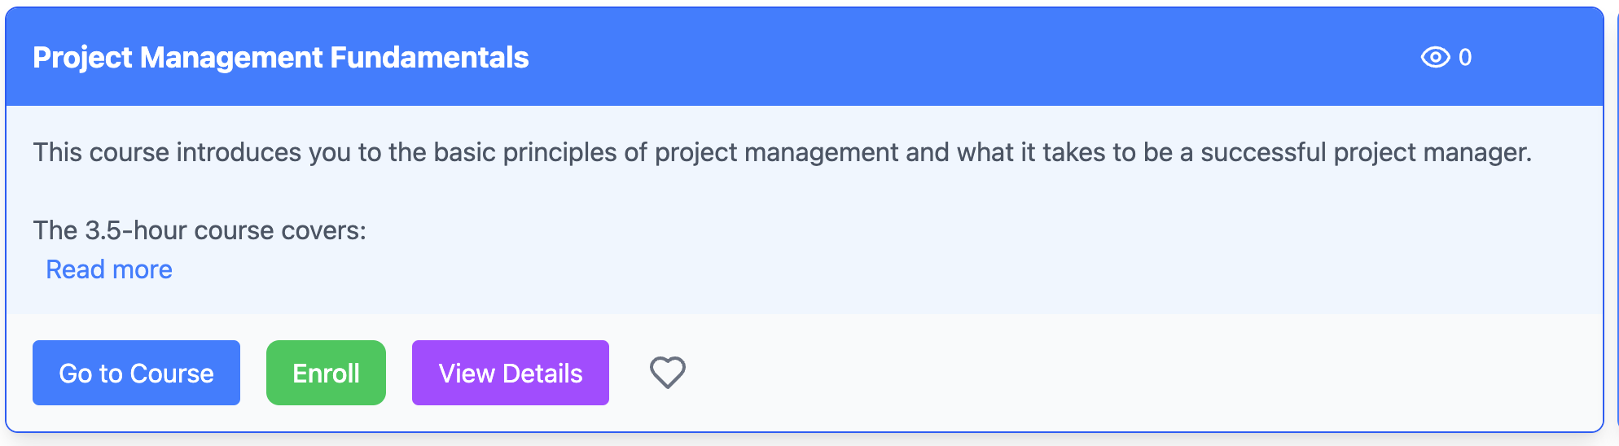
2. You will then be able to see a timer, to update your progress with. Click once to start it, click again to stop it.

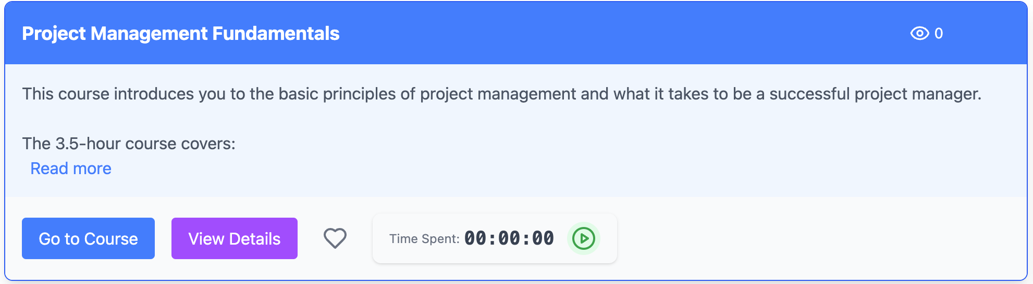

1. The timer rounds to minutes, when you stop the time spent, it will then update the backend with progress.

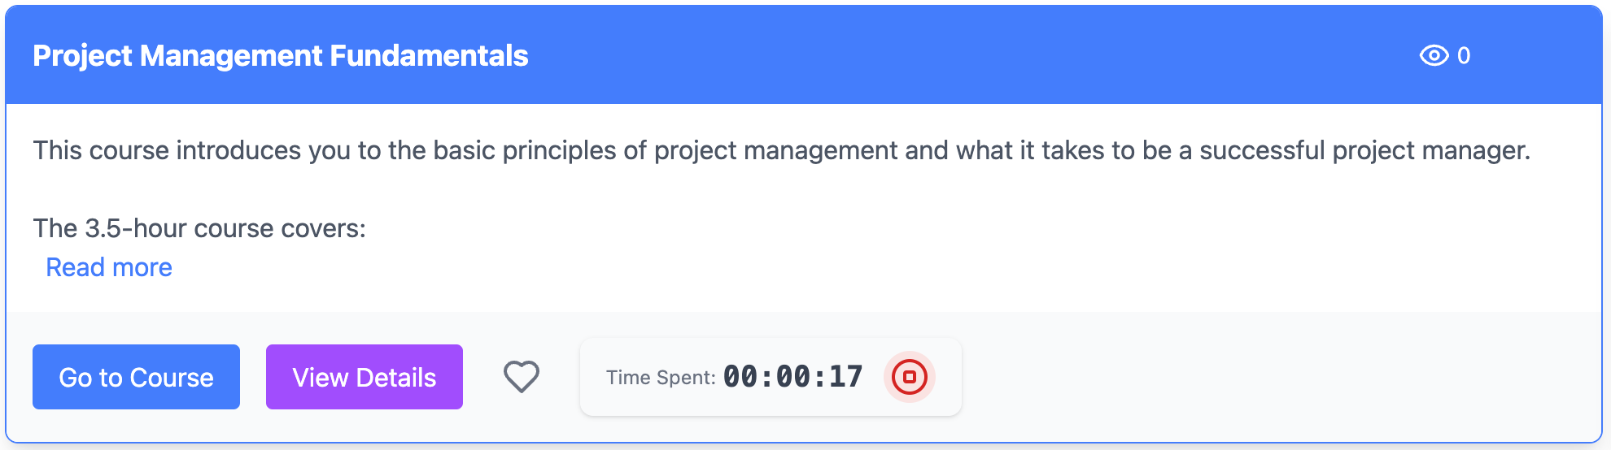

1. (Additional screenshot for seeing it rounding to 1 minute)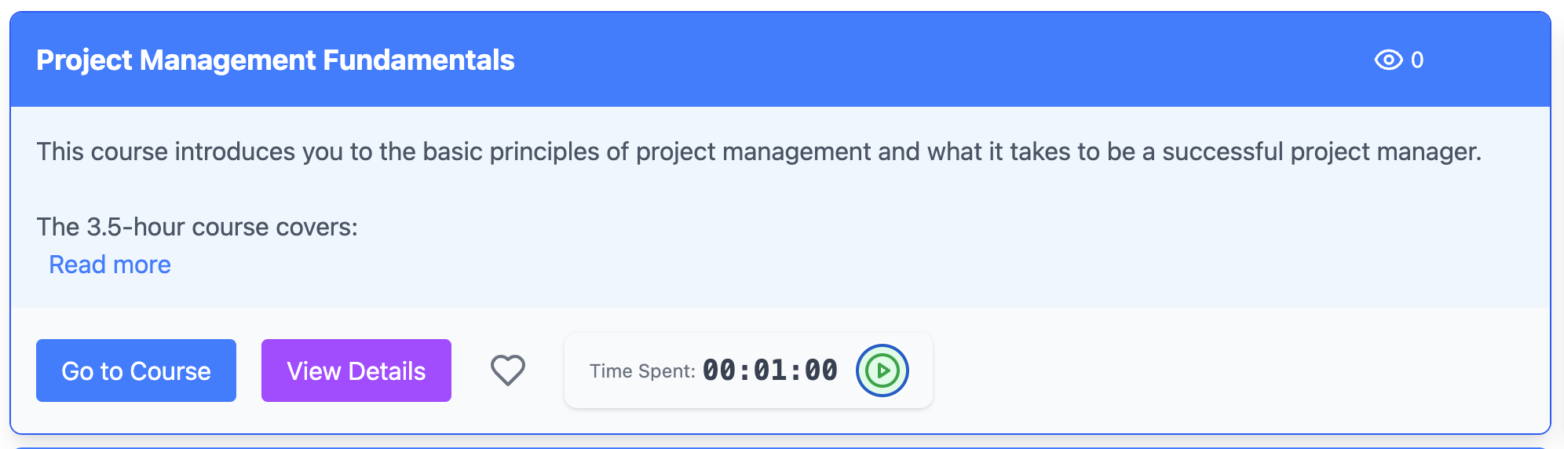

# Friends – Justin Fung

## How to Add / Remove Friends

1. Navigate to dashboard, you will be able to see a list of people (they are fake, with public avatars from Random User Generator)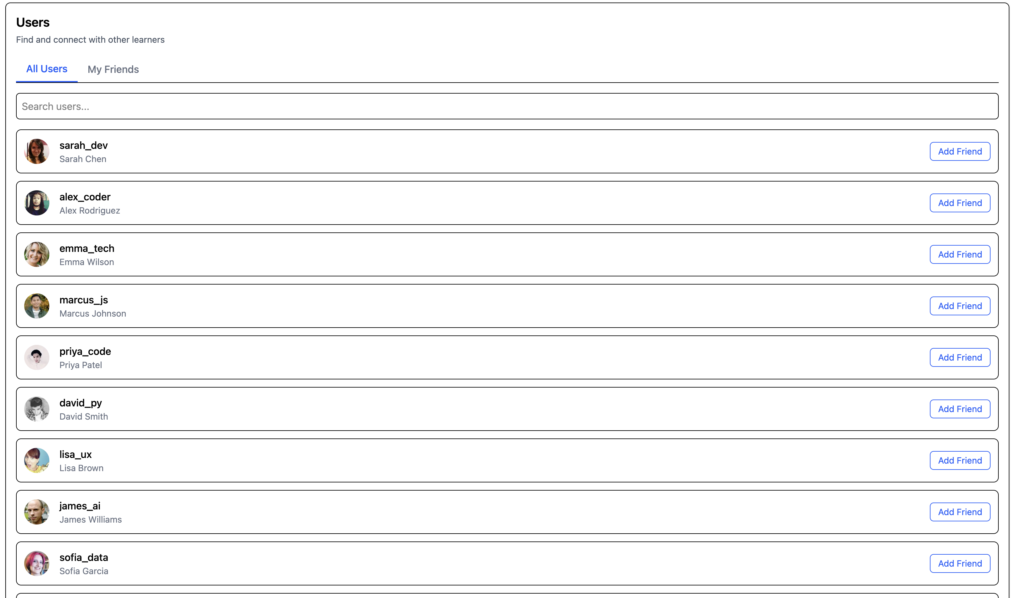
2. From here, click the Add Friend button to add other users as friends



1. After clicking on Add Friend, you will be able to remove them as friends

